Guidance Note on
AAMVS Self-Assessment Tool
1 June 2026

Introduction

1.1 Purpose of this guidance note

The purpose of this guidance note is to help users operate the Arms and Ammunition Management Validation System (AAMVS) self-assessment tool in a consistent, informed and practical way, and to support the interpretation of its results. It outlines the intended users of the tool, provides guidance on organising the process for completing the questionnaire, explains the structure of the functional sections and the scoring methodology, and supports the interpretation of scores and visual outputs for the purposes of planning, export control, and capacity development.

The guidance note does not set standards, nor does it prescribe minimum thresholds or pass marks. Instead, it clarifies how:

AAMVS operationalises existing recognized international good practices in arms and ammunition management, specifically the International Ammunition Technical Guidelines (IATG) and the Modular Small‑Arms‑control Implementation Compendium (MOSAIC).

Users can navigate the technical content and terminology.

Different stakeholders – including arms export licensing authorities, import control agencies, small arms commissions, international organisations, donors and other partners – can use the information generated to inform export-licensing decisions, tailor assistance programmes, and jointly support safe and secure arms and ammunition management aligned with national needs and priorities.
How to read this note: users filling out the tool (such as importing authorities within armed forces) are advised to focus primarily on sections 2–5. Stakeholders requesting the assessment (such as export‑licensing authorities and partners) may be most interested in section 6 on the interpretation and use of results.

1.2 Background and context
The AAMVS self-assessment tool was developed by the Geneva International Centre for Humanitarian Demining (GICHD) through its Ammunition Management Advisory Team (AMAT), in collaboration with the Small Arms Survey. The project was financed by the European Union (EU) through Council Decision (CFSP) 2022/2275 of 18 November 2022. The Council Decision tasked GICHD with developing a self-assessment tool designed to enable states to assess and share information about their arms and ammunition management capabilities in a standardized format.
One important application of the AAMVS is in export control of arms and ammunition, where licensing authorities may need to conduct diversion risk assessments of end-users prior to authorizing an export. Including end-users’ weapons and ammunition management (WAM) practices within this risk assessment provides valuable insight into diversion-prevention capabilities and overall safety and security standards.
It is important to note that the tool is not intended for cases of weapons and ammunition exports to civilian users. The tool focusses on the export of weapons and ammunition to state defence and security institutions of other nations, including the military, police and border security forces.

1.3 Objectives of the Self-Assessment Tool
The AAMVS self-assessment tool allows an end-user to provide structured information on their organizational capabilities for the safe and secure through-life management of weapons and ammunition. The aim is to facilitate the bilateral exchange of information on stockpile management capabilities for weapons and ammunition throughout the full life cycle.
The results obtained from the self-assessment can support decision-making in export control, capacity-building, and reporting requirements under various arms control frameworks such as the Global Framework for Through-life Conventional Ammunition Management (GFA), the Arms Trade Treaty (ATT) and the UN Programme of Action on Small Arms and Light Weapons (PoA).

Overview of the AAMVS Self-Assessment Tool
The AAMVS self-assessment is an Excel-based tool that contains 37 multiple-choice questions.
The tool includes:
- Tool Guide Tab
- Overview Tab
- Nine Functional Sections
- Results Tab
- Instructions Tab for printing/saving the results
Each functional section includes an introduction, questions, assessed level, evidence, and comments. Among the questions, 13 request the end-user to add supporting evidence in a provided text box. This may include an explanation of processes, authorities, structures, or procedures, as well as references to relevant laws, regulations, official documents, or reports.

Target Audience

3.1 Who should use the tool and its results
The AAMVS self‑assessment tool is primarily intended for completion by end-users of weapons and ammunition, including the military, police service, gendarmerie, or other national security institutions. It enables these entities to assess their own stockpile management practices, identify strengths and weaknesses, and to inform internal planning and requests for support.
The AAMVS was originally intended to support the exchange of information on arms and ammunition capabilities amongst partners in different countries. In this context, a state’s exporting licensing authorities can use the information as part of an assessment on diversion risks, inform decisions on arms and ammunition exports, and support planning or coordination of capacity-building activities.
The tool, however, serves a broader function. Internally, it supports capacity-building efforts by enabling end-users to prioritise areas for improvement, monitor progress over time, and communicate identified needs to relevant authorities, such as parent ministries or command structures.
In addition, the tool supports policy, planning and technical staff in comparing existing national practices against international guidelines such as IATG and MOSAIC, and in formulating plans and strategies to achieve alignment with these frameworks. When shared more broadly, the AAMVS outputs may also be used by international and regional organisations, donors and implementing partners. In such cases, the results can inform dialogue, support tailoring of assistance programmes, and help track the impact of support.
The findings generated through the AAMVS can also directly support states in meeting their reporting obligations under the UN PoA on SALW and the GFA.

3.2 Who should complete the tool
Officials completing the AAMVS questions should be primarily from within the end‑user organisation being assessed. On some occasions, depending on the circumstances, there might be a case for a central body like a small arms commission leading on the overall process. It would then delegate certain tasks to the specific end-user.
For answering the self-assessment questions, it is recommended that a small team be formed to bring together those who manage weapons and ammunition on a day‑to‑day basis and those responsible for policies, procedures, training and oversight.
Typically, this team will include:
- A designated focal point or coordinator, with sufficient seniority to convene colleagues, access relevant documentation and validate the final answers on behalf of the end-user.
- Logistics, armoury and stockpile management personnel (e.g. depot or armoury managers, supply and transport officers) who understand how weapons and ammunition are stored, issued, transported, accounted for and disposed.
- Staff responsible for training, supervision and incident reporting who can explain how personnel are prepared for their roles, how compliance is monitored, and how losses, thefts and accidents are handled.
- Where available, an internal safety, engineering or inspection officer, able to speak to infrastructure standards, risk assessments, inspections and follow‑up measures.
Depending on its mandate and structure, the team might request specific factual inputs from parent ministries or specialised agencies, for example on national legislation, overarching regulations or export‑control procedures. However, the assessment should remain focused on the capabilities and practices of the end-user itself.
The completed questions and results should be reviewed and formally endorsed by the designated authority, typically a senior level person from the appropriate ministry or armed service. This should precede sharing the outputs with others, such as relevant exporting country, external partners, or cross-government stakeholders.

3.3 Who can support or facilitate the assessment
The GICHD-AMAT is available for answering questions about the tool or supporting its use. Other ammunition technicians familiar with the Standardised Assessment Methodology from the UN SafeGuard Programme are familiar with the methodology and questions and therefore will be in a position to support the completion of the self-assessment.

How to use and complete the tool

4.1 Understanding the functional sections and questions
The AAMVS questionnaire is organised into functional sections that constitute the main components of safe and secure arms and ammunition management, based on capability enabling lines, as per the IATG. The sections are as follows:
- Legislation & Regulations
- Organization
- Safety
- Security
- Personnel
- Training
- Infrastructure
- Finance
- Materiel Acquisition
Each section contains a group of related questions so that users can assess one part of their management system at a time and then see how those parts fit into an overall capability picture. The technical aspects are more detailed in some sections, but the structure is consistent throughout, with each question scored on the same 1–5 maturity scale (with 5 representing the highest capability).
All questions are derived from established international standards and good practice, particularly the IATG and MOSAIC. Each functional section includes links to relevant reference material, allowing users to see exactly which requirements or recommendations underpin the issues being assessed. This cross‑referencing helps ensure that responses are consistent with international norms and makes it easier to identify deficiencies and gaps in national normative framework and practice.
Some questions contain technical ammunition terms relating to safety, stockpile design, surveillance and control measures. Where terminology is unclear, users should consult the IATG glossary, which provides standard definitions for key concepts across the guidelines and, by extension, within the AAMVS tool. End‑users may also wish to involve technical specialists (for example ammunition technicians, engineers or safety officers) when answering the more detailed questions, as well as using the provided cross‑references and glossary, to align national practices and language with international standards. For many questions, there is a ‘Help’ button on the right hand side of the page, and this provides supporting detail and background information.

4.2 Applying and understanding the scoring levels
Scoring in the AAMVS is designed as a structured, evidence‑based way to show how closely the current national normative framework and practice aligns with international standards and best practice. The tool uses a five‑point scale that reflects the degree of implementation, typically moving from ‘not in place’ (Level 1), ‘partially in place’ (Level 3) to ‘fully in place and aligned with international best practice’ (Level 5). Each question needs to be rated from 1 to 5, where lower scores indicate that key elements are missing or implemented on an ad hoc basis, while middle scores capture situations where policies or procedures exist but are not yet comprehensive. Highest scores are reserved for cases where practices are clearly defined, resourced, implemented, and conform to international best practice.
The mean score of all responses within a section is then automatically calculated to produce the capability maturity level for that specific area of arms and ammunition management. This approach allows users to identify, at a glance, areas of relative strength and weakness, prioritise areas for intervention and, in due course, compare progress over time.
Figure 1 below shows the user interface when opening the tab on ‘Legislation and Regulations’. This includes a free text box beneath some of the questions (labelled ‘Evidence, Processes and Notes’) for providing supplementary information.

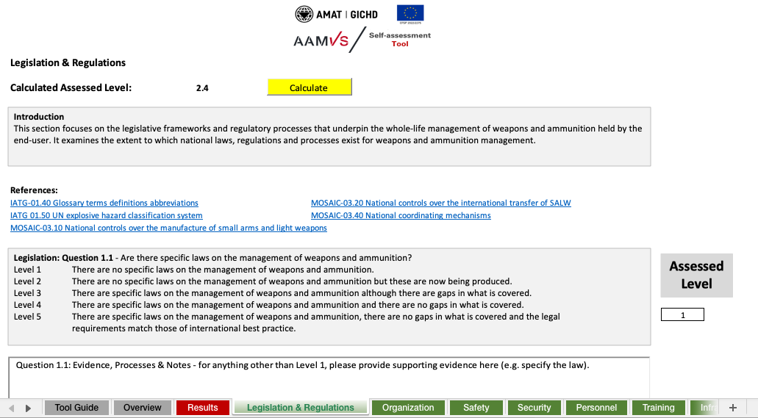

Figure 1 – Example of questions in functional section
4.3 Supplementary information
The self-assessment questionnaire encompasses the complete through‑life management of conventional small arms and ammunition, covering strategic, operational and technical levels. When answering each question, users should base their responses on existing laws, regulations, standard operating procedures (SOPs) and recent practice, rather than on planned reforms or informal workarounds. Where the tool allows for qualitative inputs or comments, users are encouraged to include references/web-links to national standards, inspections and training records. It is also useful to note any known gaps or ongoing reforms so that the results can be interpreted holistically and revisited in future cycles.

Conducting the self-assessment

5.1 Suggested process
Ideally, a small team, mainly from the end-user should complete the tool, led and coordinated by a senior official (potentially drawn from central government like the small arms commission). This team typically includes officials from the end user or governing body responsible for policy and legal frameworks, logistics and stockpile management, training, infrastructure and safety - as well as oversight of audit functions, so that answers are evidence‑based and system‑wide.
- Coordinator and scope of self-assessment:
    - a coordinator should be appointed to oversee the self-assessment process. This individual should be a senior figure from the most appropriate government body (e.g. small arms commission, import authority, army, police, other national security agency), with the authority to convene all relevant national stakeholders.
    - The scope of the self-assessment should be clearly defined, including which stocks, facilities and activities are covered. A realistic timelines should also be established for completing the questionnaire.
- A team of 4–8 officials should be assembled, under the coordinator, with expertise in the materials being imported, to address all WAM-related aspects of:
- Legislation & Regulations
      - Organization
      - Safety
      - Security
      - Personnel
      - Training
      - Infrastructure
      - Finance
      - Materiel Acquisition
      - Oversight and Audit
- The coordinator and team should:
  - Ensure a common understanding of the tool:

Be aware of the purpose of AAMVS, the 1–5 scoring scale, and how the results will be used. The importance of supporting evidence for certain questions should also be noted.
  - Gather key documents and data:

Compile relevant materials at the end-user level, including laws and regulations, SOPs, organisational charts, training plans, inspection reports, and recent incident or audit findings.
  - Complete the questionnaire section by section:

Hold short working sessions (in person or virtual) where the responsible persons propose scores and briefly explain the evidence behind them. Where views differ, the reasons should be recorded in the comments field and the lower score should be inputted.
  - Validate and consolidate responses:

Review the full set of scores for consistency and identify any obvious gaps or contradictions. Any disparities should be addressed.
- Analyse the results and identify priorities:

Examine the average scores, the bar chart and the scores for individual questions to identify systemic strengths, weaknesses and critical outliers. Where appropriate, 3-5 priority areas should be agreed where early intervention is required (potentially with the help of external partners).
  - Submit the finalised assessment:

Submit the completed AAMVS self-assessment to the senior official with designated authority to approve and release the report to the intended recipients.

5.2 Step-by-Step Instructions
To complete a self-assessment, the following steps should be taken:
- Open the AAMVS Excel file and enable ‘active content’ in the document. This is necessary for the help boxes and the scoring software to function properly. Specific instructions on how to do this can be found at the bottom of the Tool Guide tab - shown in red font.
- Read the contents of the Tool Guide tab. This step can be by-passed if the instructions in this document have been fully studied and understood.
- Open the first green functional tab (i.e. Legislation and Regulations).
- Read the introductory text and, if needed, click-on any linked references.
- For the first question, select the level (1–5) that best reflects current practice and enter it into the Assessed Level box on the right-hand side. Consultation with other stakeholders may be required to establish the exact level.
- Provide supporting evidence where requested in the box labelled ‘Evidence, Processes & Notes’.
- Repeat for all questions in the section.
- Fill out the Comments boxat the bottom of the section, where appropriate.
- Click one of the two available yellow Calculate buttons to generate the section’s mean score.
- Repeat steps 3-9 for all nine functional sections.
- Open the Results tab to view the overall, mean scores.
- Complete the Overview page with details of the self-assessors and the releasing official.
- Produce the full assessment document either as a PDF electronic file or a hard-copy, and forward to the approved recipients (e.g. the exporter state). Instructions for generating a PDF are given in the purple tab of the tool.

Figure 2 – Locations of the Calculate and Assessed Level boxes

Interpretation of Results

6.1 Analyzing and visualizing results
The Results tab shows mean scores (1–5) for each functional section. They are displayed in both graphical and tabular form. These averages should always be read in conjunction with the score for each individual question - a middle or high average, for instance, can conceal a low score on a specific question(s) and thereby can potentially mask a critical vulnerability.
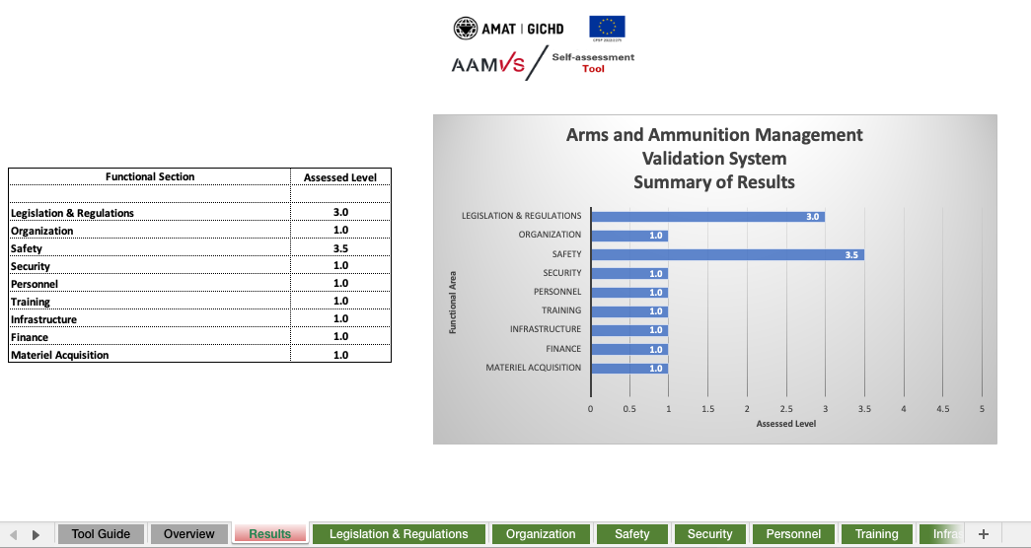

Figure 3 – the Results tab in the AAMVS tool
The bar chart is most useful for quickly spotting outliers – both high and low – and calibrating the results against the maximum achievable. More detailed analysis should focus on how the scores are distributed within each functional section, including any sharp peaks or troughs, suggesting uneven implementation.

6.2 Use of the results by importing states
In the context of planning and capacity development, the results can be used to prioritise practical, sequenced improvements. Low‑scoring sections/questions point to where targeted interventions might be needed, such as revising legislation, updating SOPs, upgrading infrastructure, or investing in training and oversight.
By comparing scores over multiple assessment cycles, authorities can track progress, demonstrate the impact of reforms and external assistance, and adjust plans as new gaps or risks emerge. In this way, the scoring and visualisation framework becomes a tool for structured dialogue, planning and resource allocation in support of safe and secure arms and ammunition management.

6.3 Use of the results by exporting states
Exporting states, particularly their licensing authorities can use AAMVS results as additional input for diversion‑risk assessments and related licensing decisions. The tool does not provide a ‘pass mark’ or pre-defined minimum standard. Exporting states will have their own expectations and standards in areas like stockpile security, accounting, tracing, and incident reporting. Their requirements might also vary from case to case.
Where self-assessment results show low or uneven scores, particularly in areas considered of special significance, exporters might decide to:
- Apply stricter conditions (e.g. post-delivery inspections)
- Request additional information
- Seek re-assurances
- Impose certain provisos (like deadlines for improvement)

Resources and references
- AAMVS Self-Assessment Tool - Geneva International Centre for Humanitarian Demining (GICHD) through its Ammunition Management Advisory Team (AMAT): http://aamvs-amat.gichd.org

- International Ammunition Technical Guidelines (IATG) – United Nations SaferGuard Programme (UN Office for Disarmament Affairs): https://disarmament.unoda.org/convarms/ammunition/iatg/

- Modular Small‑arms‑control Implementation Compendium (MOSAIC) – United Nations small arms programme (UN Office for Disarmament Affairs): https://disarmament.unoda.org/our-work/conventional-arms/small-arms-and-light-weapons/modular-small-arms-control-implementation-compendium

- Global Framework for Through-Life Conventional Ammunition Management (GFA) – UN Office for Disarmament Affairs): https://publications.unoda.org/en-us/global-framework-for-through-life-conventional-ammunition-management/

Annex

FAQs
1. Who is the AAMVS tool for?
The tool is primarily designed to assist export licencing authorities with decisions on weapons/ammunition exports to the state defence and security institutions of other countries. Those institutions will mainly be the military, police, customs and border forces - referred to in this context as ‘end-users’. The tool can also be used more broadly to inform national‑level capacity development, by identifying systemic gaps and helping authorities, partners and donors to plan targeted interventions.
2. Does the tool produce a pass/fail result and specify a minimum standard?
No. The tool does not provide a pass mark, certification or pre-defined minimum standard. It generates structured information on capability maturity (through 1–5 scores). Exporter states can interpret the provided information in line with their own needs and policies, focussing on the areas and responses that they deem of particular significance.
3. What do the scores from 1 to 5 mean?
Scores from 1 to 5 reflect the maturity of a particular aspect of arms and ammunition management, from largely absent or ad hoc (lower scores) to fully established and in line with international best practice (highest score). The mean score provides an overall maturity level for that aspect of capability, although this should always be taken alongside the scores of individual questions.
4. Are the questions based on recognised international standards?
Yes. While there are no global ‘standards’ on arms and ammunition management, there are internationally recognized good practices found in the IATG and MOSAIC. Each functional section is cross‑referenced to the relevant international provisions.
5. Who within an importing country should complete the questionnaire?
Ideally, a small team, mainly from the end-user should complete the tool, led and coordinated by a senior official (potentially drawn from central government like the small arms commission). This team typically includes officials responsible for policy and legal frameworks, logistics and stockpile management, training, infrastructure and safety - as well as oversight of audit functions, so that answers are evidence‑based and system‑wide.
6. How should the importing state prepare for filling-in the tool?
Before starting, the importing state should be clear on the scope of the assessment, identify the relevant institutions (e.g. military, police), and assemble key documents such as laws, regulations, SOPs, training plans, inspection and audit reports. Those with best knowledge of the subject should be drafted in, and there should be agreement in advance on how evidence will be documented and how consensus on scores will be reached.
7. How should export licensing authorities use the results?
Export licensing authorities can use the results as a structured contribution to diversion‑risk assessments and licensing decisions. They retain full discretion on the weighting to be applied to this information. They will have their own expectations and requirements on importers’ capabilities, informed by context, type of end-user and nature of proposed export.
The AAMVS is particularly well-suited for situations involving potential new end-user partners. It can serve as evidence of the robustness of the management system and as an early confidence-building measure. Where post-delivery verifications are being used, the AAMVS can provide valuable data that can later be validated during the verification visits.
8. How can partners and donors use AAMVS outputs?
If the importing nation decides to share the information from the self-assessment, international organisations, donors and implementing partners can use the contents to identify priority gaps, tailor assistance programmes, and monitor progress over time. The scores and qualitative comments provide an evidence base for joint planning with national authorities.
9. How often should the tool be used?
The tool can be used as a one‑off diagnostic exercise or repeated periodically (for example every 2–3 years or after major reforms) to track change over time. Comparing results across cycles helps to spot change, demonstrate progress, identify persistent gaps and adjust capacity‑development efforts.
10. Is the tool secure and confidential to use?
The AAMVS tool is an Excel‑based file that runs locally and does not require any internet connectivity, online registration, transmission to external servers or use of cloud services. End-users retain full control over both the file and the results, and can themselves decide if, when and how to share outputs with counterparts (for example by sending the original file, generating a PDF, or providing only a printed copy or selected extracts).
11. Can the results be shared externally?
Decisions on the sharing of results lies with the importing country. Some may choose to share full or partial results with partners, to inform export control decisions or to support assistance planning. Others may prefer to share only high‑level findings. Clear arrangements regarding the use of the information and access to it should be established from the outset.

https://eur-lex.europa.eu/eli/dec/2022/2275/oj/eng
See Article 11 of The Arms Trade Treaty and Criterion 7 of the EU Common Position defining common rules on governing control of exports of military equipment and technology (CFSP) 2008/944.
https://unsaferguard.org/self-assessment-tools

